OUTREACH SCHOOLS EXAMINATION BOARD

BEGINNING OF TERM III EXAMINATION 2023
PRIMARY THREE
LITERACY 1A
A
B
For Examiner’s
use only
TOTAL
Time Allowed: 2hours 15 minutes

Name: ______________________________________________

School: ______________________________________________

Class: _______________________________________________
SECTION A. (40 Marks)
- Name the body organ used for hearing.
________________________________________________________________
- In which season do people harvest water?
________________________________________________________________
- Identify any one basic need of people.
________________________________________________________________
- Which component of air supports burning?
________________________________________________________________
- Name any one animal that lives in soil.
________________________________________________________________
- Give one danger of playing with sharp objects.
________________________________________________________________
- Identify one way of preserving food.
________________________________________________________________
- How is a dustbin useful in a class?
________________________________________________________________
- Name this item made out of clay.


- Name any one bird that cannot fly.
________________________________________________________________
- Identify one condition needed for a seed to germinate.
________________________________________________________________
- Give one way of keeping the bedroom clean.
________________________________________________________________
- Identify the immunisable disease this child may be suffering from.
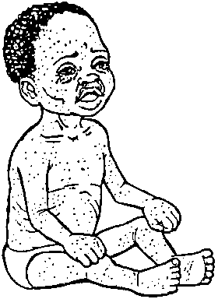

______________________________________________
- Name any one food stuff we get from plants.
________________________________________________________________
- How can a P.3 child keep his / her hair clean?
________________________________________________________________
- How is part marked W useful to a bird?
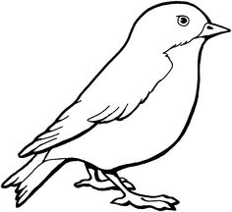
W

__________________________________________________
- Name any one cause of natural changes in the environment.
________________________________________________________________
- How is a zebra crossing useful to pedestrians?
________________________________________________________________
- Identify the element of weather that farmers need to winnow seeds.
________________________________________________________________
- Name any one material we use to build our houses.
________________________________________________________________
- Which clouds give us rain?
________________________________________________________________
- Why is a goat grouped under living things?
________________________________________________________________
- Name any one member of a nuclear family.
________________________________________________________________
- What is the main natural source of light?
________________________________________________________________
- Why are we advised to boil water for drinking?
________________________________________________________________
- Which part of a sugarcane plant stores food?
________________________________________________________________
- Name one group of people who work in a hospital.
________________________________________________________________
- Give any one way of caring for our environment.
________________________________________________________________
- Write any one danger of electricity at home.
________________________________________________________________
- Name any one fuel used at home.
________________________________________________________________
- Why are snakes grouped under wild animals?
________________________________________________________________
- How are floods a problem to crop farmers?
________________________________________________________________
- Why should people wash hands before eating?
________________________________________________________________
- How many legs does a cockroach have?
________________________________________________________________
- Give one role of a father at home.
________________________________________________________________
- Name the young one of a cow.
________________________________________________________________

The diagram below is of a garden tool. Use it to answer questions 37 and 38.

- Name the garden tool.
________________________________________________________________
- Write one way the above garden tool is useful to people.
________________________________________________________________
- Give one property of air.
________________________________________________________________
- Write one way you would help sick people at home.
________________________________________________________________
SECTION B:
- (a) Name this tool used by first aiders.


__________________________________________________________
(b) Name any two things found in the above tool.
(i) _____________________________ (ii) __________________________
(c) Why are casualties given first aid?
__________________________________________________________
- (a) Identify any one natural source of water.
__________________________________________________________
(b) Write any two ways in which water sources can get
contaminated.
(i) __________________________________________________________
(ii) __________________________________________________________
(c) Give one way of caring for water sources.
__________________________________________________________
- (a) Give any two uses of the sun to people.
- __________________________________________________________
- __________________________________________________________
(b) How can the sun be dangerous to people?
__________________________________________________________
(c) Name one way people can manage sunny weather.
__________________________________________________________
- (a) Write any two common accidents at home.
- _____________________________ (ii)__________________________
(b) Give one effect of accidents to people.
__________________________________________________________
(c) How can we prevent accidents at home?
__________________________________________________________
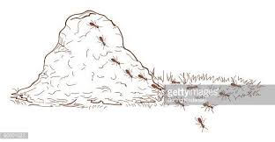
The diagram below is of an animal habitat. Use it to answer question 45.

- (a) Name the animal habitat shown above.
__________________________________________________________
(b) Name the animals that build the habitat above.
__________________________________________________________
(c) Give one danger of the above animals to farmers.
__________________________________________________________
(d) Why do animals need habitats?
__________________________________________________________
- (a) Give the food value we get from each of these foodstuffs.
- Fish _____________________________________________________
- Matooke ________________________________________________
(b) Give one way in which food can get contaminated.
__________________________________________________________
(c) Name one disease spread through eating contaminated
food.
__________________________________________________________
- (a) What are domestic birds?
__________________________________________________________
(b) Write any one example of domestic birds.
__________________________________________________________
(c) Name any two things we can get from domestic birds.
(i) ___________________________ (ii) ___________________________
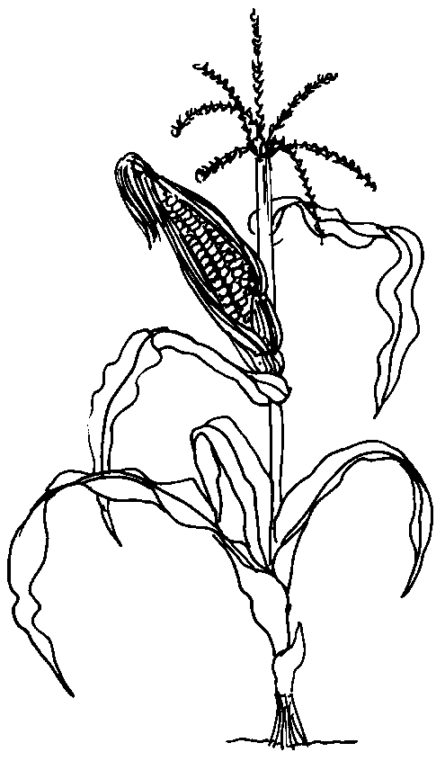
Below is a diagram of a plant. Use it and answer questions that follow.

K
L

- (a) Name the part marked L on the plant.
L __________________________________________________________
(b) How is part K useful to the plant above?
__________________________________________________________
(c) Give one way of caring for the plant above.
__________________________________________________________
(d) Name the best season for harvesting the above plant.
__________________________________________________________
- Match correctly.
Animal weapon
Bee horns
Snake sting
Dog fangs
Cow teeth
- Bee ________________________________________________
- Snake ________________________________________________
- Dog ________________________________________________
- Cow ________________________________________________
- (a) Name any two things we use to keep our bodies clean.
- __________________________________________________________
- __________________________________________________________
(b) Why are we advised to keep our bodies clean?
__________________________________________________________
(c) Give one way of keeping the body clean.
__________________________________________________________
- (a) Why do farmers mulch their gardens?
__________________________________________________________
(b) Name any two materials used in mulching.
(i) ____________________________ (ii) __________________________
(c) Give one other good farming practice.
__________________________________________________________
The diagram below is of an animal. Use it to answer question 52.
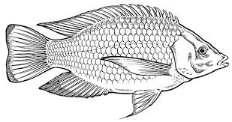
Y
X

- (a) Name the part labelled Y.
__________________________________________________________
(b) Give the use of part X to the animal.
__________________________________________________________
(c) How does the above animal move in water?
__________________________________________________________
(d) Give one use of the above animal to people.
__________________________________________________________
- (a) Name any two play materials children make at school.
- __________________________ (ii) ____________________________
(b) Give any two things children use to make the play materials.
(i) ______________________________ (ii) ________________________
- (a) How are the following body organs useful to a P.3 child?
- Skin _____________________________________________________
- Tongue __________________________________________________
(b) Give any two ways of keeping each of the body organs
above healthy.
- Skin _____________________________________________________
- Tongue __________________________________________________
- (a) Name the main body part of an insect on which these parts
are found.
- Feelers ________________________________________________
- Spiracles ________________________________________________
(b) Give the use of each of the above parts to an insect.
(i) feelers ________________________________________________
(ii) spiracles ________________________________________________
************************** END ***************************

